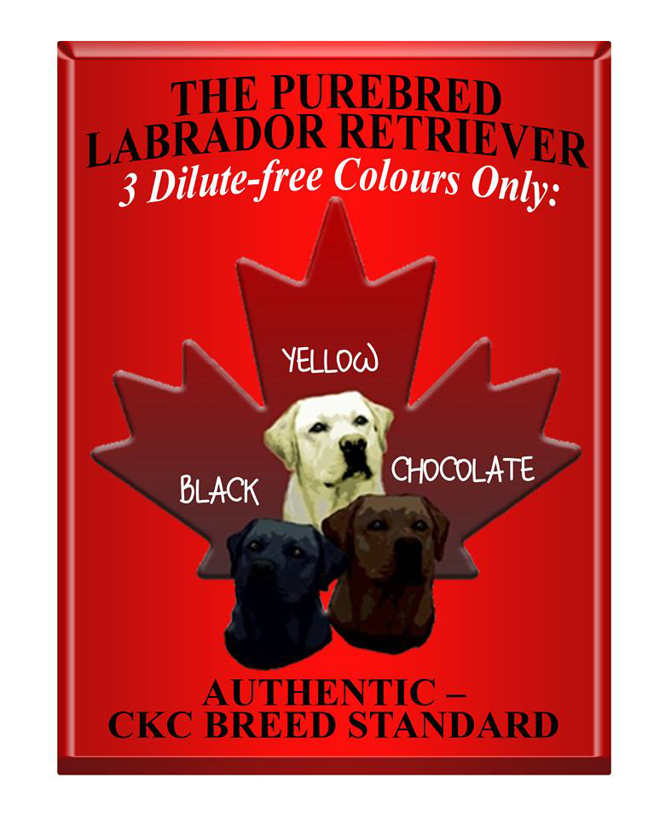
Origin and Purpose
The Labrador Retriever originated and developed on the island of
Newfoundland as an all purpose waterdog and functional retriever. The
breed was preserved in England after anti-dog legislation almost
decimated the breed in its homeland. The breed is noted for its love of
retrieving and water, for its excellent nose, soft mouth, intelligence and
biddable temperament. Extraordinary versatility allows Labradors to
excel as hunting, service, and therapy dogs; in search and rescues; in drug
and bomb detection; as family companions, and in performance and
field events.
General Appearance
Medium sized, strongly built, compact, short-coupled, powerful, athletic;
broad in skull; broad and deep through chest and ribs; broad and
powerful over loins and hindquarters. A water resistant double coat,
otter tail, and sound temperament are essential breed characteristics.
Proportion and Size
Proportions: Distance from withers to elbow approximately equal to
distance from elbow to ground; length from point of shoulder to point
of rump very slightly longer than height at withers. A well -balanced
dog is the ideal.
Size: Ideal height at withers: Dogs 22 ½ - 24 ½ inches (57 - 62 cm);
Bitches 21 ½ - 23 ½ inches (54 -60 cm). Weight commensurate with
height and with the breed’s function as a medium sized, powerful,
active retriever. Approximate weights: Dogs 60-80 lbs (27.27-36.36
kilos); Bitches 55-75 lbs (25-34.09 kilos).
Coat and Colour
Coat Distinctive Feature: Outer coat short, straight, although a slight
wave down the back is also correct; dense without feathering, giving
fairly hard feel to the touch; soft, dense weather-resistant undercoat.
Color: Wholly black, yellow or chocolate. Small white spot on chest
permissible. Yellows range from light cream to fox red with variations in
the shadings on ears, under parts, hocks, and down the back. Chocolates
range from light sedge to dark chocolate.
Pigmentation: Black in blacks and yellows; brown or liver in chocolates.
Pigmentation fading to a lighter shade in yellows not to be penalized.
Head and Skull: A kindly, gentle expression is characteristic of the
breed. Skull broad with defined stop; clean-cut without fleshy cheeks.
Muzzle of medium length, powerful, not snipey. Muzzle and skull on
parallel planes and of approximately equal lengths. Nose wide; nostrils
well developed. Eyes: Medium size, expressing intelligence and good
temper; almond or diamond shape, not round; color dark brown or
hazel. Ears: Medium sized; hanging close to head and set rather far
back. Mouth: Jaws and teeth strong; scissor bite.
Neck
Clean, strong, medium length, good reach; set into well-placed
shoulders.
Neck
Clean, strong, medium length, good reach; set into well-placed
shoulders.
Forequarters: Shoulders long and sloping. Forelegs well boned and
straight from elbow to ground when viewed from either front or side.
Legs of medium length, not short. Pasterns: Strong, short, sloping
slightly from the perpendicular. Feet: Compact, round, medium sized;
well arched toes; well developed pads.
Body
Chest of good width and depth; well-sprung ribs. Brisket extends to the
elbows. Straight, level topline. Loins wide, short-coupled and strong.
Hindquarters
Well developed, great power, not sloping to tail; well turned stifle. Hocks
well let down; cowhocks highly undesirable.
Tail Distinctive Feature: Very thick towards base, straight, gradually
tapering towards tip, medium length, free from feathering, but clothed
thickly all round with thick, dense coat, giving ‘‘rounded’’ appearance
described as ‘‘otter’’ tail. Tail may be carried ‘happily’ but not at more
than a 35-degree angle with the back. Tail an extension of the topline and
balances the dog.
Gait Gait/Movement: Free, effortless, powerful, covering adequate ground
with good reach and drive; straight and true in front and rear. Tending to
converge at higher speeds.
Faults
Any departure from the foregoing ideal should be considered a fault. The
seriousness with which the fault should be regarded must be in
proportion to its degree and its effect upon the dog’s function as a
working retriever.
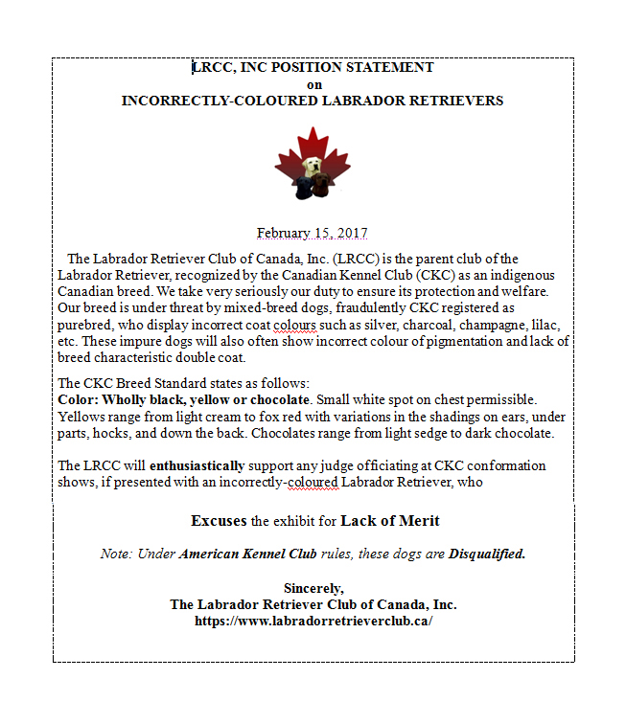

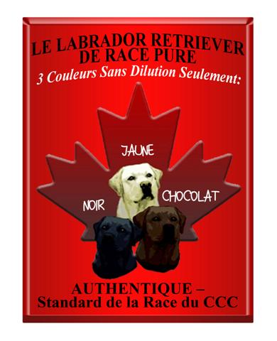

Do you want to learn more about Labrador Retrievers??
You have come to the right place
The Illustrated Breed Standard approved and produced by the Labrador Retriever Club of Canada Inc is available at a minimal cost from the LRCC Inc Request for the Labrador Breed Standard or by calling (403) 255-4814.
Cheques to be made payable to the Labrador Retriever Club of Canada Inc and mailed to
38 - Hays Drive S. W.,
Calgary, AB,
T2V 3C3
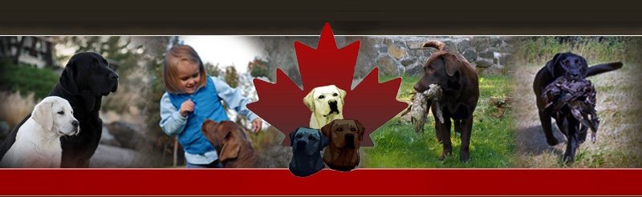

Club Info

"Silvers are not a breed standard recognised color for the Labrador Retriever"

